### Installing MYSQL

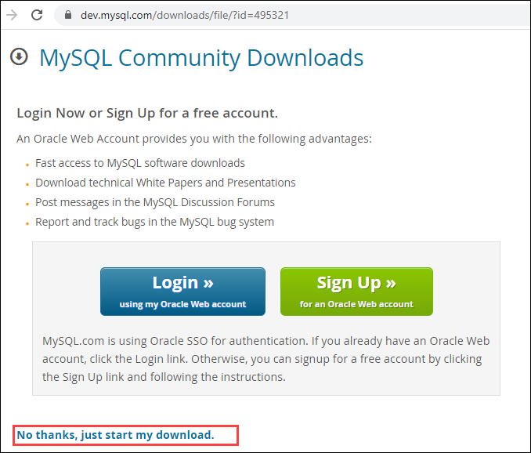

## ✅ ****Installing MySQL on Windows****

### Step 1: Download MySQL Installer

1. Go to the official MySQL website: https://dev.mysql.com/downloads/installer/
2. Choose **MySQL Installer for Windows** (usually the "Windows (x86, 32-bit), MSI Installer").
3. Download the **full** version (includes MySQL Server and other tools).

### Step 2: Run the Installer

1. Double-click the downloaded .msi file.
2. Choose **Setup Type**:
   * Developer Default (recommended)
   * Server only (for minimal install)

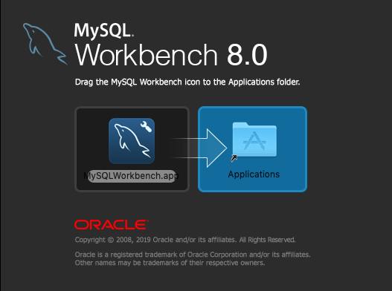

### Step 3: Install Required Components

1. The installer checks for required software (e.g., Visual C++ Redistributable). Install if needed.
2. Click **Next** and let it download and install MySQL Server and other tools (like MySQL Workbench).

### Install MySQL

### Install MySQL Step 4: Configure MySQL Server

1. Choose: Instal MySQL
   * **Stan** **Install MySQL dalone MySQL Server** or default configuration.
   * Set port to **3306** (default).
2. Set a **root password**.
3. Optionally create additional MySQL users.
4. Complete configuration and click **Finish**.

### Step 5: Open MySQL

* Launch **MySQL Workbench** or use the **MySQL Command Line Client**.
* Log in with your root password.

## ✅ ****Installing MySQL on macOS****

### Step 1: Use Homebrew (Recommended)

1. Install Homebrew (if not already):

bash

CopyEdit

/bin/bash -c "$(curl -fsSL https://raw.githubusercontent.com/Homebrew/install/HEAD/install.sh)"

Install MySQL bash

brew install mysql

1. Start MySQL:

bash

CopyEdit

brew services start mysql

1. Secure MySQL:

bash

CopyEdit

mysql_secure_installation

1. Log in:

bash

CopyEdit

mysql -u root

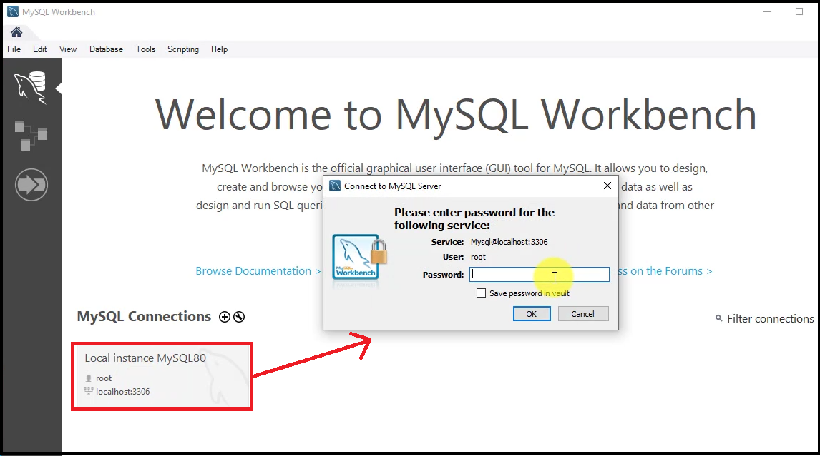

## ✅ ****Installing MySQL on Ubuntu/Linux****

### Step 1: Update Packages

bash

CopyEdit

sudo apt update

### Step 2: Install MySQL Server

bash

CopyEdit

sudo apt install mysql-server

### Step 3: Secure the Installation

bash

CopyEdit

sudo mysql_secure_installation

### Step 4: Log in

bash

CopyEdit

sudo mysql

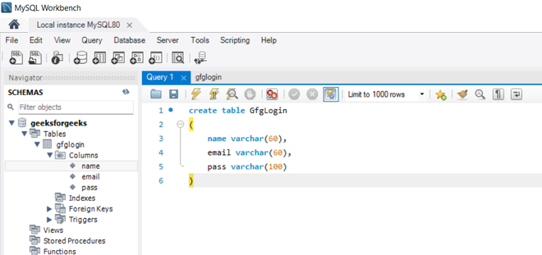v

Bottom of Form